**The Past (ES3, ES5) & Present (ES6) of Javascript**

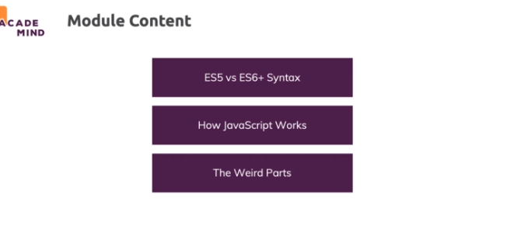

**ES5 vs ES6+ ("Next Gen JS") - Evolution of JavaScript**

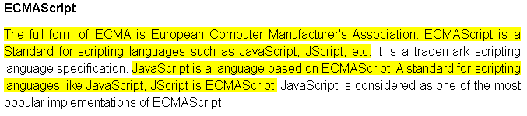

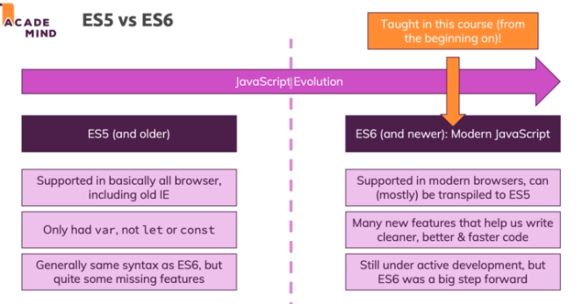

**var vs let & const - Introducing "Block Scope"**

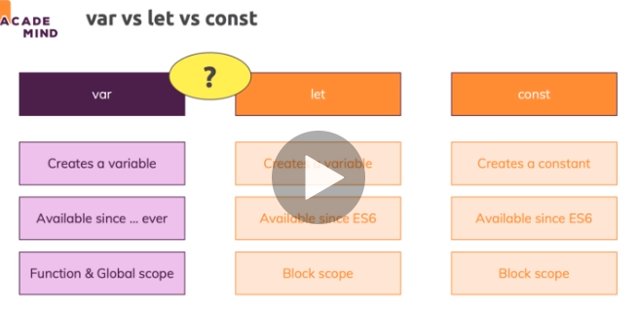

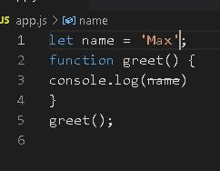

https://paper-attachments.dropbox.com/s_856593340D0C3BC26D14EE8DD695A55D286D82D595462C80F26862A7144EC95E_1632288201709_image_2021-09-22_105321.png

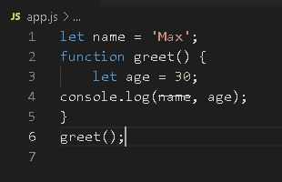

https://paper-attachments.dropbox.com/s_856593340D0C3BC26D14EE8DD695A55D286D82D595462C80F26862A7144EC95E_1632288336061_image_2021-09-22_105535.png

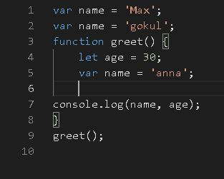

https://paper-attachments.dropbox.com/s_856593340D0C3BC26D14EE8DD695A55D286D82D595462C80F26862A7144EC95E_1632288518443_image_2021-09-22_105838.png

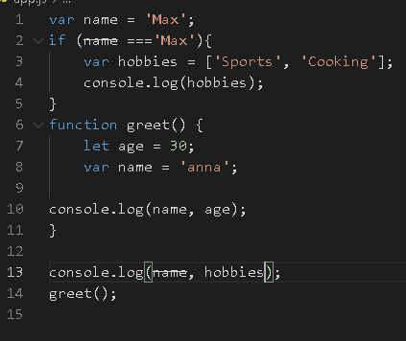

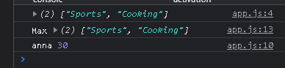

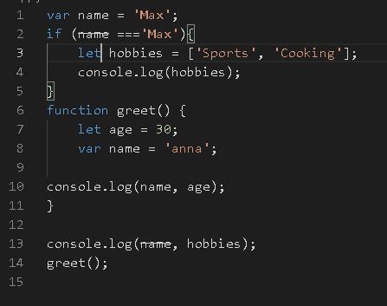

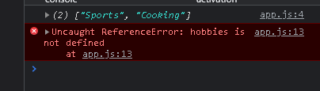

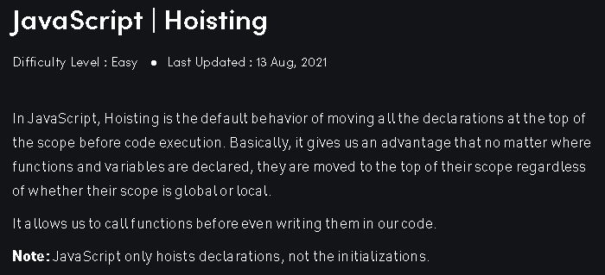

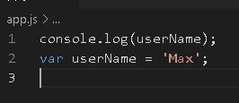

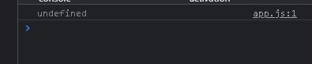

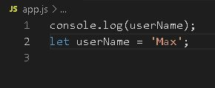

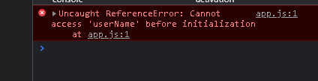

**Strict Mode & Writing Good Code**

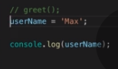

https://paper-attachments.dropbox.com/s_856593340D0C3BC26D14EE8DD695A55D286D82D595462C80F26862A7144EC95E_1632304305606_screenshot-www.udemy.com-2021-09-22-15-21-15-897.png

Javascript has a special mode which you can turn on and that's the strict mode. It was introduced with ES5 and even though modern Javascript syntax as you're learning it in this course already prohibits some of the things you can rule out with strict mode, it might still be worth turning it on

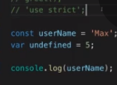

https://paper-attachments.dropbox.com/s_856593340D0C3BC26D14EE8DD695A55D286D82D595462C80F26862A7144EC95E_1632304668498_screenshot-www.udemy.com-2021-09-22-15-27-41-882.png

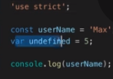

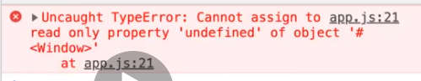

**How Code is Parsed & Compiled**

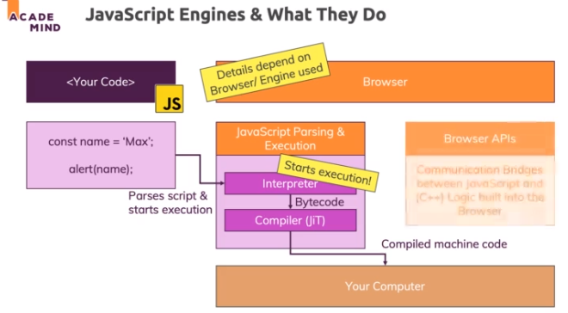

**Inside the JavaScript Engine - How the Code Executes**

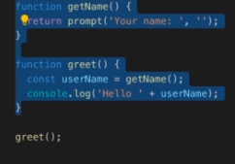

https://paper-attachments.dropbox.com/s_856593340D0C3BC26D14EE8DD695A55D286D82D595462C80F26862A7144EC95E_1632305219500_screenshot-www.udemy.com-2021-09-22-15-36-52-018.png

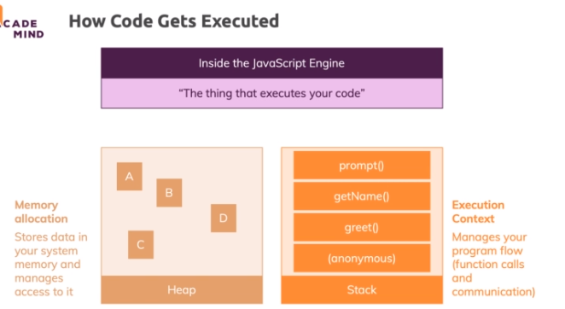

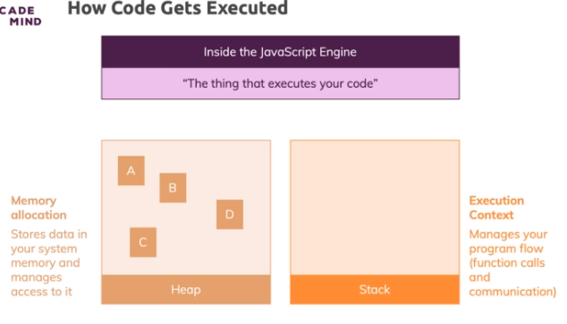

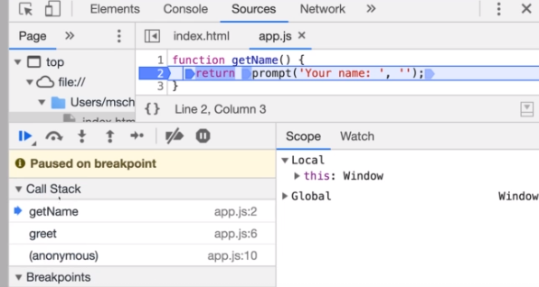

**JavaScript Language vs Browser APIs**

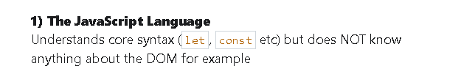

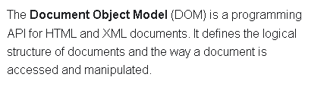

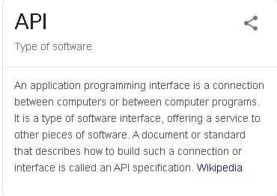

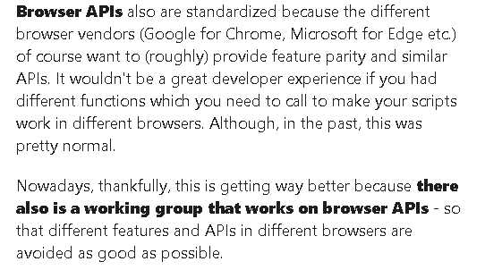

**Primitive vs Reference Values**

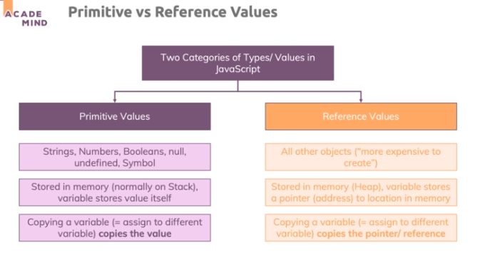

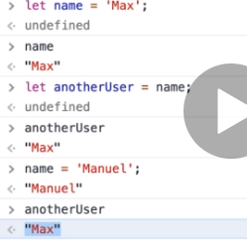

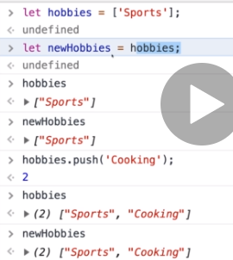

**Garbage Collection & Memory Management**

